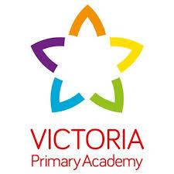

**LKS2 Summer 1 News!**

**Summer 1!**

**How time has flown this half term, I can’t believe we’re heading into Summer already! This half term I have seen some amazing pieces of work - especially our children’s writing! From Hansel and Gretel to Billy Goats Gruff our children have amazed us this half term with their amazing stories!**

**In Summer 1 we are able to share these achievements in the parents consults on the 23rd and 24th of April. In our learning we will be covering geometry (shape) in maths, letters of complaint in writing and we will be looking at activism in history!**

**Important dates**

**15th April – Return to School**

**18th April - Class Photos**

**23rd and 24th April - Parents Consults**

**24th April – Extreme Readers Trip**

**2nd May - Wellbeing Trip**

**6th May - May Bank Holiday**

**20th May - Poetry Slam Launch**

**23rd May - Maths City Trip**

**24th May - Break Up**



**DT**

**This half term, it is our turn to do DT and I am excited to announce that we will be looking at structures! Within this unit we will be learning how structures are strong and what materials can be used to make different structures.**

**P.E**

**This half term we will be starting to look at athletics in preparation for sports day in Summer 2! This will cover both track and field events for the big day!**

**History**

**This half term, we are learning about activism. Within this unit we will be looking specifically at women’s rights and how the last centuries have shaped the world we live in today. We will cover the suffragettes and even women closer to home and how they changed the country!**

**Early Bird**

**Arrive in school as soon as you so can so we can do our early morning activities together. Doors open at 8:30. Breakfast club continues to be available from 7.30am.**

**Reading books**

**Each morning, your child has a chance to show off the reading they’ve been doing at home to their teachers. Remember to bring in your reading diary and earn those dojos!**

**Science**

**In science, we will be looking at biology! We will be looking at different hazards in the environment and how they can endanger different animals and their habitats.**