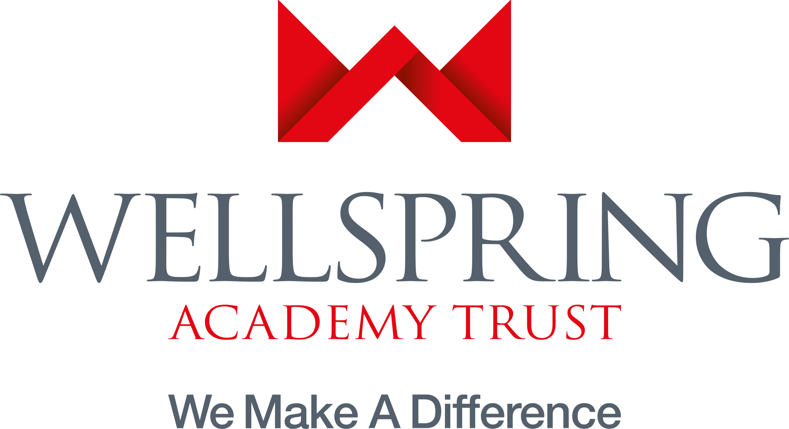
Victoria Primary Academy
Ivy Ave
Leeds
West Yorkshire LS9 9ER
Tel: 0113 248 2449
info@vpaleeds.co.uk
www.vpaleeds.co.uk

TEACHING ASSISTANT

32.5 Hours Per Week, Monday to Friday, 8.30am - 3.30pm

Term Time Only + 5 Inset Training Days (39 weeks per year)

Victoria Primary Academy is currently looking for a team player to join our brilliant team. We are passionate about offering the very best quality provision it is possible to create, and we are on a journey to make that a daily reality for our little people - because we simply believe they deserve nothing less. We have a strong desire to ensure that our children have everything that they need to become successful adults when they leave us, with high achievement and a strong moral code that will stay with them beyond their years at Victoria. If you are committed to bringing sunshine into the lives of and improving the life chances of young people - then this could be the right place for you.
We have high expectations of our Teaching Assistants, with the successful candidate required to form a teaching partnership with their teacher and play a full part in all aspects of the school day.
If you are someone who has:
- recent and relevant experience of leading learning with young learners across a range of needs.
- a thorough understanding of engaging children and eliciting their best.
- a determined approach to the achievement of all children and doing ‘whatever it takes’ to ensure children experience success.
- enthusiasm for a role in a school environment which sees pupils at its heart.
- a commitment to your own professional development and ambitions for your future.
- an appetite for collaboration with colleagues.
…then we want to hear from you.

What can we offer?

- Fantastic kids.
- A supportive, hardworking, and dedicated team.
- Passion, commitment, energy, enthusiasm.
- Effective systems and supportive leadership.
Candidates are encouraged to come and visit school to see for yourself the work that we do.

Job live 08/06/2021
Job closes noon 24/06/2021
Interviews 02/07/2021

