Victoria Primary Academy
Ivy Ave
Leeds
West Yorkshire LS9 9ER
Tel: 0113 248 2449
info@vpaleeds.co.uk
www.vpaleeds.co.uk

Post Title: | SENDCO
Reporting to: | Executive SENDCO | Salary: | L1-4
An opportunity has arisen for a dynamic individual to join our team in Leeds in this multi-faceted role.

This is an exciting opportunity for a SENDCO to take the next step in their career. Drawing upon your experience and working under the direction of an Executive SENDCO, together you will drive SEND provision across both Ebor Gardens and Victoria Primary Academies. We are looking for a highly driven, knowledgeable and passionate individual who believes all children are entitled to the very best primary school experience it is possible to deliver. Working closely with the Leadership Team, this non-teaching position will enable the right individual to secure exceptional SEND provision throughout our academies and enable a knowledgeable and empowered staff team to unlock the potential of our beautiful children.
Ebor Gardens and Victoria Primary Academies are a part of Wellspring Academy Trust, a successful values-driven Multi-Academy Trust which is fully committed to making a difference to the lives and life chances of the young people and the communities we serve. Under the Executive Leadership of Sam Bailey, we work in strong partnership with our partnership academies in Barnsley and have the luxury of high-quality specialist settings Springwell Learning Community, Greenacre and Joseph Norton within the Wellspring family of schools. A high level of expertise, training and research informed practice are, therefore, ours to draw upon. We are fully committed to the professional growth of our colleagues and in this role, you will be invited to participate in high quality CPD, leading to your rapid development as an innovative and highly effective leader in SEND. Those with an ambition to develop their skills and to grow as a leader should be especially keen to apply. There will be a broad range of opportunities for you to realise your professional vision and ambitions both within the school and the Trust.

We value our staff; collegial working at all levels is central to our culture. High quality induction training and ongoing professional development support are guaranteed.

We are interested in hearing from people who:

• Have the national award to special educational needs coordination or the commitment to complete within 3 years;

• Are committed and passionate about learning and ensuring high quality SEND provision for all;

• Can lead, inspire and enable others;

• Have a commitment to working with children who require excellence in all that we do to ensure they thrive.

• Are aspirational about their own career pathway and are committed to professional development.

As the Trust continues to grow, our roles offer pathways for ambitious and dynamic individuals who are determined to make a difference. We value our people, and your professional development is guaranteed.

Collegial working at all levels is central to our culture. As a SENDCO, you will be central to a strong culture of networking to facilitate the sharing and development of best practice in the primary age range. There will be a broad range of opportunities for you to realise your professional vision and ambitions within the Trust.

Wellspring Academy Trust is committed to safeguarding and promoting the welfare of our pupils. All posts are offered subject to enhanced DBS checks. References will be taken up prior to interview.

If you are currently living overseas or have lived / worked overseas in the last five years please be aware that you will be required to provide an overseas criminal records check from the country/countries you have resided in, if you are the preferred candidate for the post.

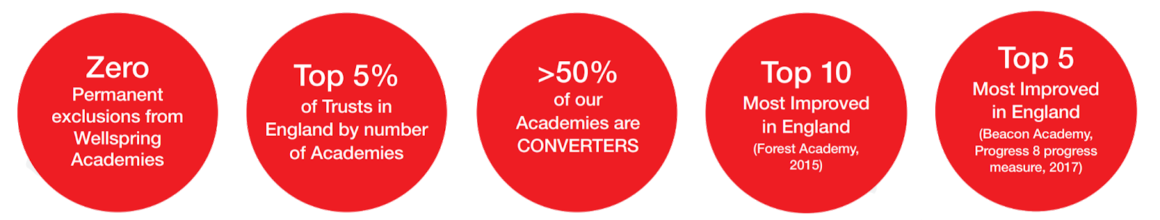
Reporting to | Executive SENDCO
Duration of Post | Permanent
Hours | Full-time
Salary | L1-4
Start Date | September 2021
Closing Date | 14th May 2021
Interview Date | W/B 26th May 2020
Applications | Visits to the academy are warmly welcomed, with the opportunity to discuss the role with Executive SENDCO Emma Nuttall. To arrange an appointment or to return your completed application, please contact Tina Connolly t.connolly@wellspringacademies.org.uk

www.wellspringacademytrust.co.uk

