A guide to using Google Classroom
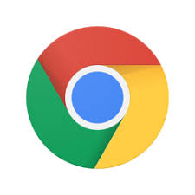
Step 1: The correct browser
Ensure you have the Google Chrome internet browser. Google classroom will work on all internet browsers but works the best when used alongside Google Chrome.

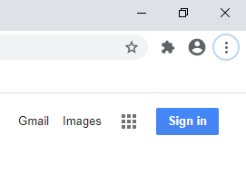
Step 2: Logging in
Once you have google chrome, it is time to log in. When you open chrome, you will see a ‘sign in’ sign in the top right (or a letter if you are previously signed in). Click this.
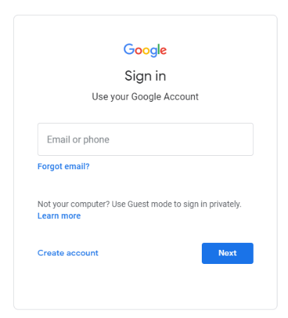
Type in your username and password. These will be provided for each student.

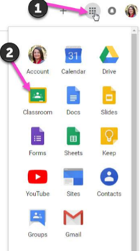

Step 3: Navigating the ‘Classroom’

Once logged in, click the 9 dots (called a waffle!) and click classroom.

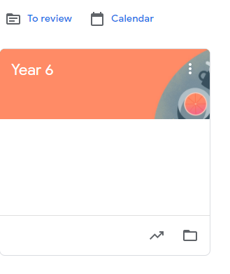
Here you will be shown each class that the child’s account is linked to. Click the appropriate class for your child.

This is where the magic begins! Once in, you will have the opportunity to look at live ‘streams’ of comments that the teacher has written, view classwork that has been set and see other students online. These can be accessed through clicking the appropriate buttons at the top.
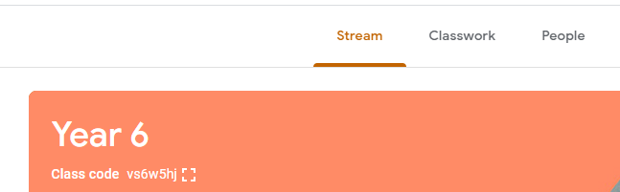
Step 4: Completing work
This next part can seem daunting, but follow these steps and the page is much easier to navigate.
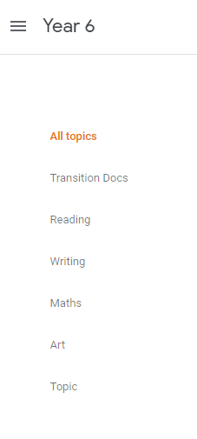

First, you will notice that down the side you have a variety of lessons. You can either keep this as ‘all topics’ (which will show everything) or you can select individual ones.

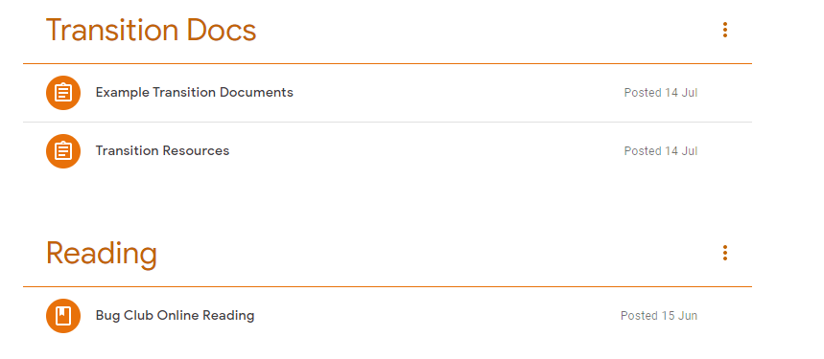
Next, you will see work that has already been posted and when. Click on the work you should be doing.

Once clicked, you will get an overview of the work.
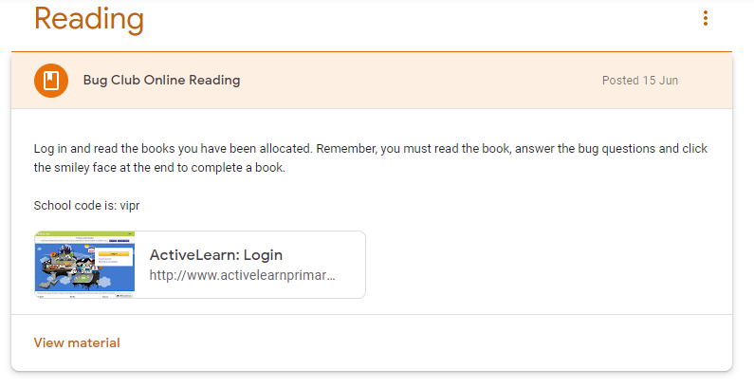

To see a more detailed view, or to write a comment, click ‘view material’

Once clicked, follow the link or the task set. Many tasks will be based in one of our online learning platforms, such as timestable rockstars or frog play. These passwords will be sent out shortly.

For any more information or if you have and queries please contact:
Years 1 and 2: year1vpa@gmail.com year2vpa@gmail.com
Years 3 and 4: Year3vpa@gmail.com Year4vpa@gmail.com
Years 5 and 6: UKS2team@vpaleeds.co.uk

